From: <https://www.youtube.com/playlist?list=PLqq-6Pq4lTTYFJxC9NLJ7dSTI5Z1WWB6K>

Chapter 21



Object attributes by default are public

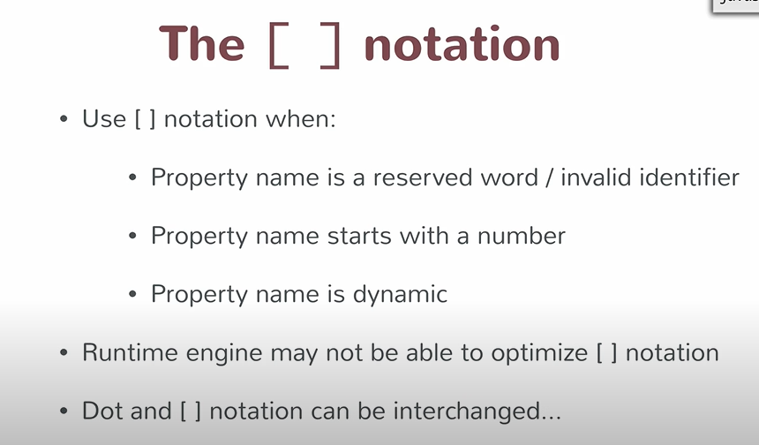



Now person.middlename is null instead of undefined.